**Floor Cleaning Project**

**Introduction**

With the advancement of technology, robots are getting more attention of researchers to make life of mankind comfortable. Robotic Technology has changed the world around us and is continuing to impact the way we do things. Robotic technology transformation from the Past to Present surrounds almost everyone in today’s society, and it affects both our work and leisure activities.

In recent years, robotic cleaners have taken major attention in robotics research due to their effectiveness in assisting humans in floor cleaning applications at homes, hotels, restaurants, offices, hospitals, workshops, warehouses and universities etc. Basically, robotic cleaners are distinguished on their cleaning expertise like floor mopping, dry vacuum cleaning etc. Each cleaning and operating mechanism of robotic floor cleaners has its own advantages and disadvantages.

This work aims at building such a cleaning bot which operates in autonomous mode as well in manual mode with the features of scheduling for specific time and bag less dirt container with auto-dirt disposal mechanism.

**Why did we decide to make it?**

We decide to build this project by considering the uses associated with this project. This floor cleaning bot will save time and will be ideal for people with mobility issues. Using this people can clean their home when they are away with minimal maintenance. It would lessen the human effort to great extent.

**Materials and Methods**

Components used:

* Hardware:

|  |  |  |  |
| --- | --- | --- | --- |
| S. No. | Components | Picture | Description |
|  | Arduino UNO R3 | Arduino Uno - R3.jpg | The Arduino UNO is a widely used open-source microcontroller board based on the [ATmega328P](https://en.wikipedia.org/wiki/ATmega328P) microcontroller and developed by [Arduino.cc](https://en.wikipedia.org/wiki/Arduino). The board is equipped with sets of digital and analog input/output (I/O) pins that may be interfaced to various expansion boards (shields) and other circuits. The board features 14 Digital pins and 6 Analog pins. It is programmable with the [Arduino IDE](https://en.wikipedia.org/wiki/Arduino#software) Integrated Development Environment) via a type B USB cable. It can be powered by a USB cable or by an external 9 volt battery, though it accepts voltages between 7 and 20 volts. |
| 2. | Ultrasonic Sensor | C:\Users\DELL\AppData\Local\Microsoft\Windows\INetCache\Content.MSO\91EDA8EE.tmp | As the name indicates, ultrasonic sensors measure distance by using ultrasonic waves. The sensor emits an ultrasonic wave and receives the wave reflected back from the target .Ultrasonic Sensors measure the distance to the target by measuring the time between the emission and reception. |
| 3. | Arduino Motor Driver shield | C:\Users\DELL\AppData\Local\Microsoft\Windows\INetCache\Content.MSO\18243E1A.tmp | A very easy and safe is to use popular L293D chip. It is a 16- pin chip. The pin configuration of a L293D along with the behaviours of motor for different input conditions is given in fig. 4. The L293D is designed to provide bidirectional drive currents of up to 600-mA at voltages from 4.5 V to 36 V. When an enable input is high, the associated drivers are enabled. Also their outputs are active and in phase with their inputs. When the enable input is low, those drivers are disabled, and their outputs are off and in the high-impedance state. With the proper data inputs, each pair of drivers forms a full-H (or bridge) reversible drive suitable for solenoid or motor applications. |
| 4. | Battery for motors | C:\Users\DELL\AppData\Local\Microsoft\Windows\INetCache\Content.MSO\E207BD38.tmp |  |
| 5. | A Scotch Brite scrub pad | Image result for scotch brite scrub pad in circle |  |
| 6. | Home made Vacuum Cleaner | C:\Users\DELL\AppData\Local\Microsoft\Windows\INetCache\Content.MSO\302F144F.tmp |  |
| 7. | Infrared Sensor | Image result for infrared sensor | An infrared sensor is an electronic instrument which is used to sense certain characteristics of its surroundings by either emitting and/or detecting infrared radiation. Infrared sensors are also capable of measuring the heat being emitted by an object and detecting motion. |

* Software:

1. Arduino IDE

The Arduino Integrated Development Environment - or Arduino Software (IDE) - contains a text editor for writing code, a message area, a text console, a toolbar with buttons for common functions and a series of menus. It connects to the Arduino and Genuine hardware to upload programs and communicate with them.

1. Fritzing

Fritzing is an open-source hardware initiative that makes electronics accessible as a creative material for anyone. It is a software tool and a community website for Processing and Arduino, fostering a creative ecosystem that allows users to document their prototypes, share them with others, teach electronics in a classroom, and layout and manufacture professional pcbs.

Method:

Step 1: Mechanical Modelling

Step 2: Circuit Designing

The connections are as follows:

1. A battery of 12 V is connected to Breadboard.
2. The positive terminal of battery is connected to Arduino V-IN.
3. The Arduino’s 5 V is connected to Ultrasonic sensor VCC.
4. The ground of Arduino is connected to ground of Ultrasonic sensor.
5. The Arduino’s D2, D3, D4, D5 is connected to N1, N2, N3, N4 terminals of Motor Driver respectively.
6. The Arduino‘s D6 and D7 is connected to two resistors of 220 ohm.
7. The Arduino’s D9 is connected to Servo Motor.
8. The Arduino’s A1 pin is connected ECHO pin of ultrasonic sensor.
9. The Arduino’s A2 pin is connected to TRIGGER pin of Ultrasonic sensor.
10. Connection of n-p-n transistor:

* Collector is connected to D. C Motor‘s positive terminal.
* Base is connected to resistance.
* Emitter is connected to 12 V supply.

1. The motor driver is connected to two DC motors.

Step 3: Software

**Schematics**

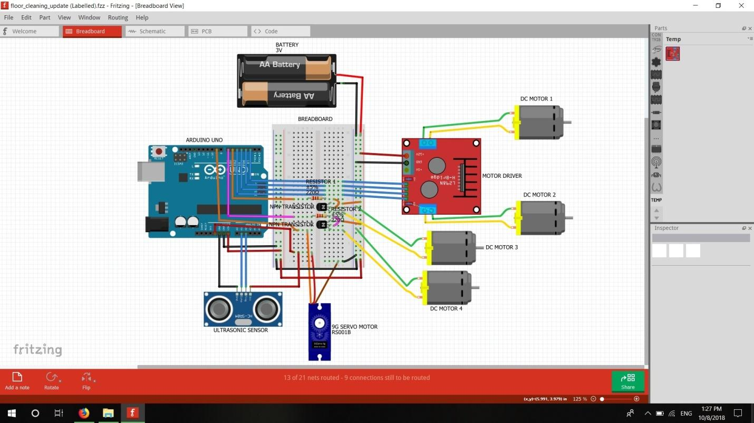

**Cad Model**

**Future scopes**

* A cheaper and user friendly Vacuum Cleaner robot can be developed with two different mode of controlling (Manual and Autonomous mode) using an Arduino Board with more electronics functionality.
* Battery monitoring, self-charging, lighter body weight and to set alarm on/off time manually are the future scope of this project.